Great Britain
QUIZ
Answer these questions about Great Britain.

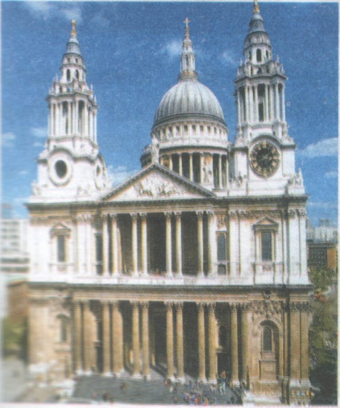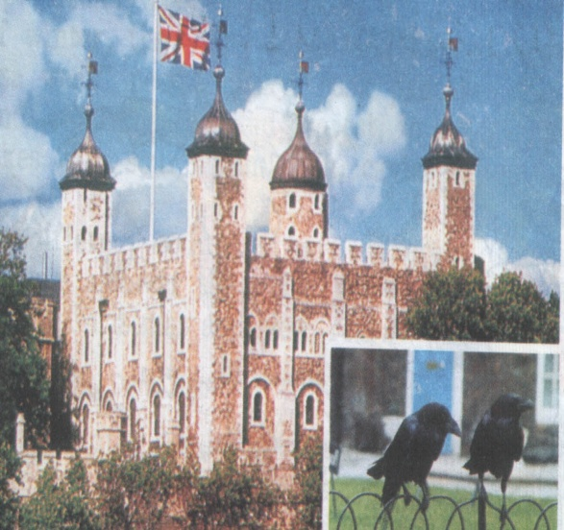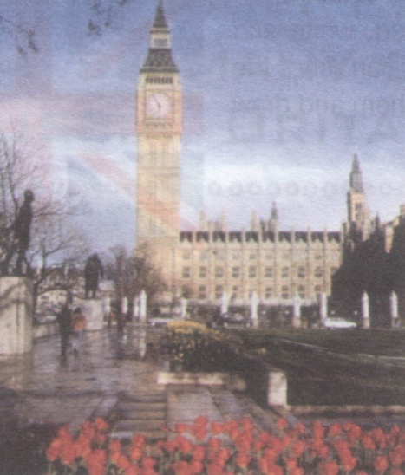
1 2) 3)
1) Where is the seat of the British Government?

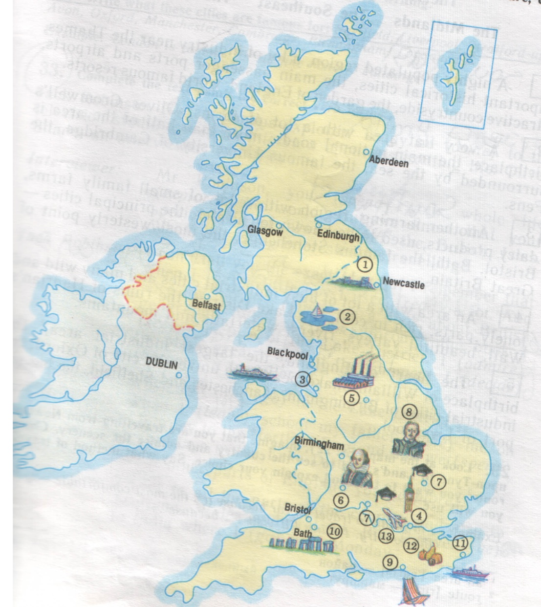

2) What parts does the United Kingdom consist of? (Name and mark them on the map.)
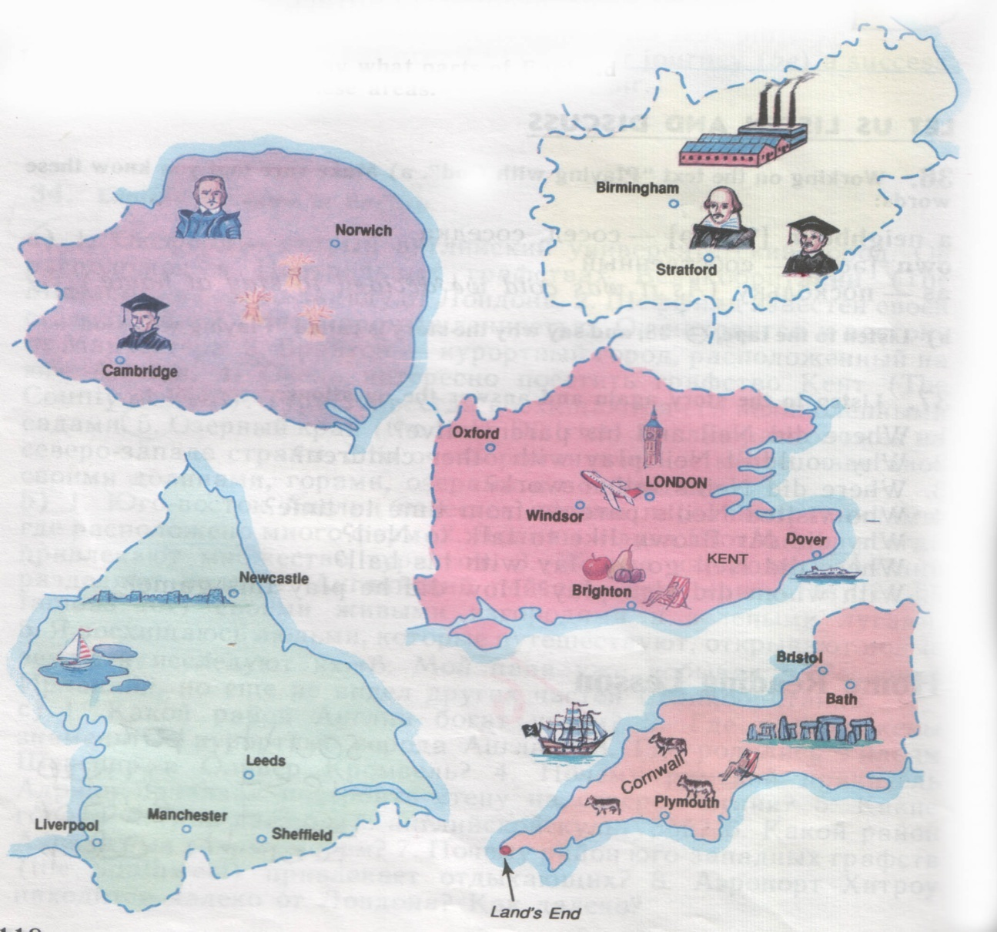
3) Look at the pictures. Say what parts of England they show?

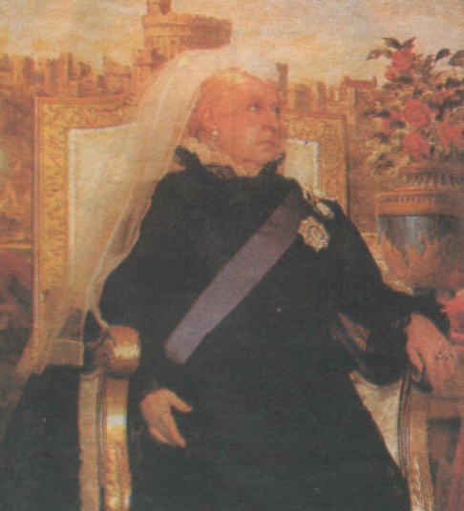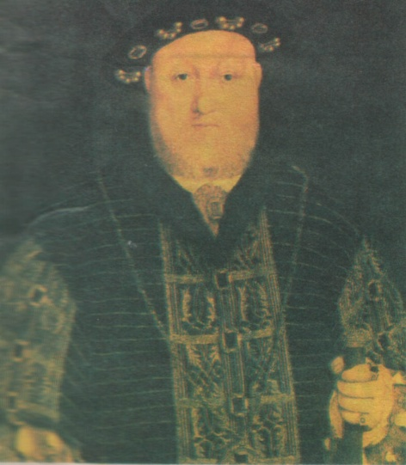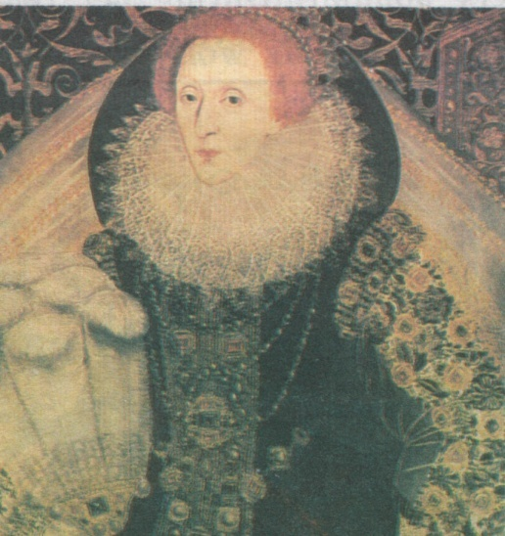
Queen Victoria King Henry VIII Queen Elizabeth I

4) Who is known for saying: “I know I have the body of a weak and feeble person, but I have the heart and stomach of a King…”

5) When did the Great Fire of London start?

a) 1066 b) 1666 c) 1766

- Make the right choice:
The Union Jack is…
a) the flag of the UK c) the flag of Wales
b) the flag of Scotland d) the flag of England

7) Match the columns:
- The symbol of England
- The symbol of Scotland
- The symbol of Northern Ireland
- The symbol of Wales
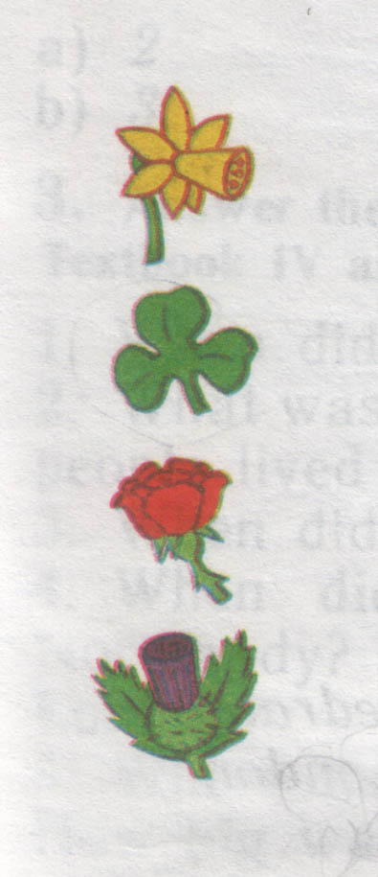

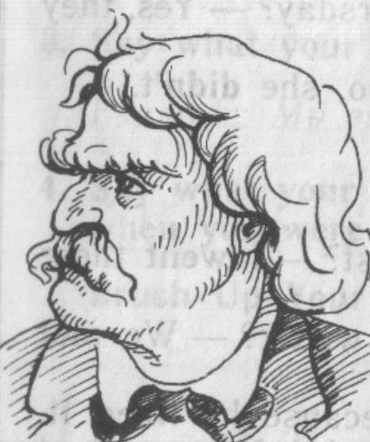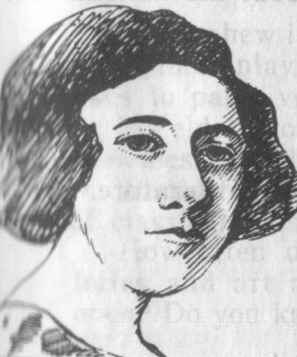
Mark Twain (1835-1910) Agatha Christie (1890-1976)

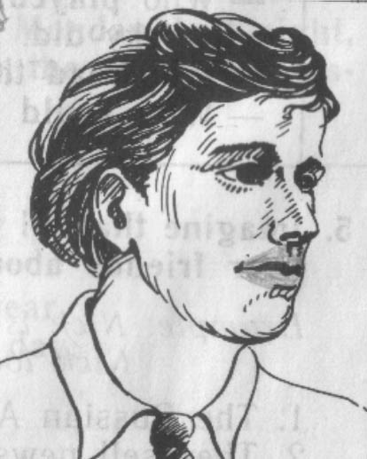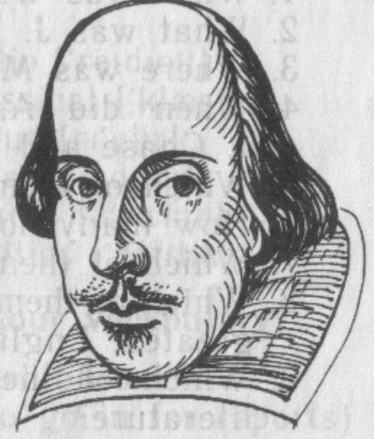

Jack London (1876-1916) William Shakespeare (1564-1616)

- Who was born in Stratford-upon Avon?

- What holiday is on the 25th December?
St. Valentine’s Easter Christmas

- Where can you see ravens in London?
Buckingham Palace
Westminster Abbey
The Tower of London

- What do the English often put in their tea?
Jam milk fruit

- How many pence are there in 1pound?
100 1000 10

- Which of these cities are in England?
London, New York, Oxford, Manchester, Ottawa, Stratford, Liverpool,
Toronto, Bristol, Salt Lake City, Sydney, Cardiff, Cambridge.
- What’s the name of the biggest river in London?
The Avon The Trent The Thames
- Who wrote “the Tale of Peter Rabbit?”

Hogarth Beatrix Potter Lewis Carroll

